源码： // Copyright © 2016年 张皓. All rights reserved.

//

import Foundation

for i in 1...9 {

for t in 1...i{

var a = i\*t

print("\(i)x\(t)=\(a)",terminator: " \t")

}

print("\n")

}

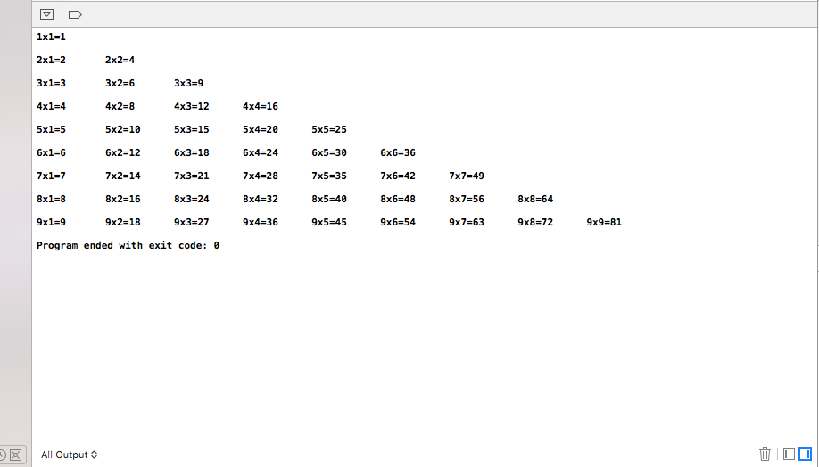截图：